Final Report
Artificial Intelligence

Name:- Harjot Singh
Roll number- 54
Registration N.o:- 11808963
Section:- K18KK

- Introduction : With the advances in technology people always rely on the machines to get their work done,thereby get lazy .Moreover,their lifestyle peculiarly the eating habits has changed drastically due to this .People are not aware how much they need to eat in order to make the body functionally active .With this project ,people would get to know how much intake of calories are good to be in shape .
Hence, to make their fitness path a bit smoother and to enhance their experience, I have created an application to provide a broader approach in providing a better living through nutritious plan to the users.

- Abstract: The Project "Personal Dietician " helps the user to take care of his health through a chatbot .It basically breaks down the macro nutrients (Protein,Carbohydrates,Fat)required to the human body according to the weight and height of the individual .

- Scope: The future scope in this application are going to be the improved GUI of this application.A proper workout schedule and routine will be provided to the user for a better fit life. Less use of data base and more use of Artificial Intelligence. This is a application which can also be developed as a Android and IOS application
- Implementation:
It's implemented using python code and has 2 python files
with it ,namely Modules.txt and Finals.txt.
Module is defined as a file containing a set of functions you want to include in your application.For instance ,abc module in python provides the infrastructure for defining abstract base classes ABCs in Python it contain one or more abstract methods.
The future implementation in this application is going to be the improved GUI of this application. Less use of data base and more use of Artificial Intelligence.

- Output:
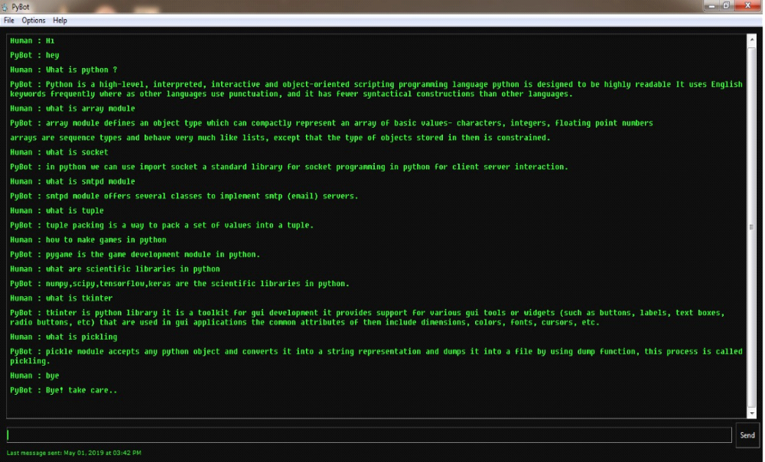

- Libraries Used :
NLTK consists of the most common algorithms such as tokenizing, part-of-speech tagging, stemming, sentiment analysis, topic segmentation, and named entity recognition. NLTK helps the computer to analysis, preprocess, and understand the written text.

TEXTBLOB :
It provides a simple API for diving into common natural language processing (NLP) tasks such as part-of-speech tagging, noun phrase extraction, sentiment analysis, classification, translation, and more.

SPEECH RECOGNITION:
Speech-to-Text enables developers to convert audio to text by applying powerful neural network models in an easy-to-use API. The API recognizes more than 120 languages and variants to support your global user base.It basically translates speech into text .

PYAUDIO:
PyAudio is required if and only if you want to use microphone input.PyAudio provides Python bindings for PortAudio, the cross-platform audio I/O library. With PyAudio, you can easily use Python to play and record audio on a variety of platforms

- References : https://www.statista.com/statstics/650748/health-fitness-app-usage-usa
https://nevonprojects.com/artificial-intelligence-dietician/
https://www.ijrter.com/papers/volume-3/issue-2/artificial-intelligence-dietician.pdf

